

PYTHON PROGRAMMING
ASSIGNMENT 3 – CO3
PYTHON DATA STRUCTURES: IMPLEMENTATION AND ANALYSIS

Student Name: Praveen L
Register Number: 1924260137
Department: Artificial Intelligence and Data Science
Course: CSA0806 – Python Programming
Assignment: Assignment 3 – CO3
Submission Date: 03/11/2026
GitHub Repository Link: https://github.com/arun060308-code/CSA0806-Python-Program/tree/main/Assesmemnt%203

Abstract
This assignment demonstrates Python data structures including lists, tuples, dictionaries, sets, list comprehensions and nested data. Seven practical problems are implemented and analysed. The programs process rainfall records, bus-stop coordinates, farmer complaints, elective registrations, sensor readings, railway timetables and phone contacts. Each task includes program design, implementation, testing, output and time/space complexity. Small experiments compare alternative approaches. Execution timings shown in this report were captured in the preparation environment and may vary on another computer.

Contents
- 1. Introduction and system requirements
- 2. Q1 – Lists and slicing: Daily rainfall records
- 3. Q2 – Tuples, mutability and copying
- 4. Q3 – Dictionaries: Farmer helpline complaints
- 5. Q4 – Sets: Elective registration clash detection
- 6. Q5 – List comprehension: Cleaning sensor readings
- 7. Q6 – Nested data: Railway timetable
- 8. Q7 – Contact merging from first principles
- 9. Overall results and discussion
- 10. Conclusion
- 11. References
- 12. Appendix – execution evidence

1. Introduction and System Requirements
The objective is to apply Python data structures to store, access and manipulate unstructured data. The work follows the sequence Design → Implementation → Analysis → Evaluation.
Component | Requirement
Processor | Dual-core processor or above
RAM | 4 GB or above
Storage | At least 500 MB free
Software | Python 3.x and VS Code / IDLE
Libraries | Python standard library only

Functional requirements
- Store and process sequential readings using lists and slicing.
- Use immutable tuples as coordinate keys and understand copying.
- Count and group text using dictionaries.
- Use set operators to identify common and unique registrations.
- Clean data with loops, comprehensions, map() and filter().
- Represent railway data using nested dictionaries, lists, tuples and sets.
- Merge contacts using normalised keys and set-based values.

2. Q1 – Lists and Slicing: Daily Rainfall Records
Aim: To store daily rainfall values, calculate weekly totals, identify wettest and driest weeks, calculate a 7-day moving average and find dry days.

Design and implementation
A list is suitable because rainfall readings are ordered by day, can be indexed and sliced, and can be extended as new readings arrive. The program generates 365 sample readings using random.seed(42) so the demonstration is repeatable.
Pseudocode – running moving average
IF number of readings < 7, return empty list
sum7 = sum of first 7 readings
append sum7 / 7
FOR each next day i from 7 to n-1:
sum7 = sum7 + readings[i] - readings[i-7]
append sum7 / 7
RETURN averages

Slicing explanation
Expression | Meaning
readings[7:14] | Values at indexes 7 through 13 (seven values).
readings[-7:] | The last seven readings.
readings[::7] | Every seventh reading, starting at index 0.

List operation costs
Operation | Typical time | Reason
append() | O(1) amortised | Adds at the end; occasional resizing.
insert(i, x) | O(n) | Later elements must shift.
pop() at end | O(1) | Removes final item.
pop(i) | O(n) | Later elements shift.
sort() | O(n log n) | Comparison-based sorting.
Naive moving average: there are n−6 windows, and each window sums 7 values, giving 7(n−6) additions (O(7n), equivalent to O(n) for fixed window 7). Running-sum method performs 7 initial additions and one addition plus one subtraction for each later window: 7 + 2(n−7), which is O(n).

Program
# Q1 - Daily Rainfall Records
import random
import time
def naive_average(readings, window=7):
if len(readings) < window:
return []
return [sum(readings[i:i+window]) / window
for i in range(len(readings) - window + 1)]
def running_average(readings, window=7):
if len(readings) < window:
return []
result = []
current = sum(readings[:window])
result.append(current / window)
for i in range(window, len(readings)):
current += readings[i] - readings[i-window]
result.append(current / window)
return result
def analyse(readings):
weekly = [sum(readings[i:i+7]) for i in range(0, len(readings), 7)]
if readings:
wettest = max(enumerate(weekly, 1), key=lambda x: x[1])
driest = min(enumerate(weekly, 1), key=lambda x: x[1])
maximum = (max(readings), readings.index(max(readings)))
minimum = (min(readings), readings.index(min(readings)))
else:
wettest = driest = maximum = minimum = None
dry_days = [i+1 for i, value in enumerate(readings) if value == 0]
return weekly, wettest, driest, maximum, minimum, running_average(readings), dry_days
if __name__ == "__main__":
random.seed(42)
readings = [random.randint(0, 30) for _ in range(365)]
weekly, wettest, driest, maximum, minimum, averages, dry = analyse(readings)
print("Number of readings:", len(readings))
print("First 5 weekly totals:", weekly[:5])
print("Wettest week (week, mm):", wettest)
print("Driest week (week, mm):", driest)
print("Maximum daily rainfall (mm, zero-based index):", maximum)
print("Minimum daily rainfall (mm, zero-based index):", minimum)
print("First 5 moving averages:", [round(x, 2) for x in averages[:5]])
print("Dry days (first 10 day numbers):", dry[:10])
print("\\nTiming comparison (seconds)")
for n in (365, 36500, 365000):
data = [random.randint(0, 30) for _ in range(n)]
t0 = time.perf_counter(); naive_average(data); t1 = time.perf_counter()
running_average(data); t2 = time.perf_counter()
print(n, "naive=", round(t1-t0, 6), "running=", round(t2-t1, 6))
print("Empty input:", running_average([]))
print("Short input:", running_average([1, 2, 3, 4, 5, 6]))

Execution output and timing
Number of readings: 365
First 5 weekly totals: [68, 119, 42, 87, 111]
Wettest week (week, mm): (11, 140)
Driest week (week, mm): (53, 6)
Maximum daily rainfall (mm, zero-based index): (30, 48)
Minimum daily rainfall (mm, zero-based index): (0, 2)
First 5 moving averages: [9.71, 7.43, 10.29, 10.71, 10.43]
Dry days (first 10 day numbers): [3, 19, 25, 39, 194, 211, 241, 245, 303, 309]
\nTiming comparison (seconds)
365 naive= 5.3e-05 running= 3.2e-05
36500 naive= 0.010948 running= 0.006283
365000 naive= 0.120131 running= 0.03434
Empty input: []
Short input: []
For an empty list or fewer than seven values, both functions return an empty list. A late reading inserted at its date uses list.insert(), which is O(n) because elements shift. A list remains suitable for a 365-day record; for frequent middle insertions, a date-keyed dictionary or deque-based stream may be better.

Alternative concept and complexity
A deque(maxlen=7) keeps only the latest seven values and supports append/removal at the ends in O(1). Maintain a running sum: subtract the outgoing value before it is discarded and add the incoming value. The stream calculation is O(n) time and O(7)=O(1) extra window space. A dictionary keyed by date provides average O(1) lookup/update by date, but computing a chronological moving average requires ordered dates or sorting them (O(n log n)); the dictionary itself uses O(n) space. The full list uses O(n) space, while a streaming deque uses O(1) window space.

Result
The rainfall program calculates weekly totals, extremes, moving averages and dry-day positions. The running-sum method avoids repeatedly summing each seven-value slice.
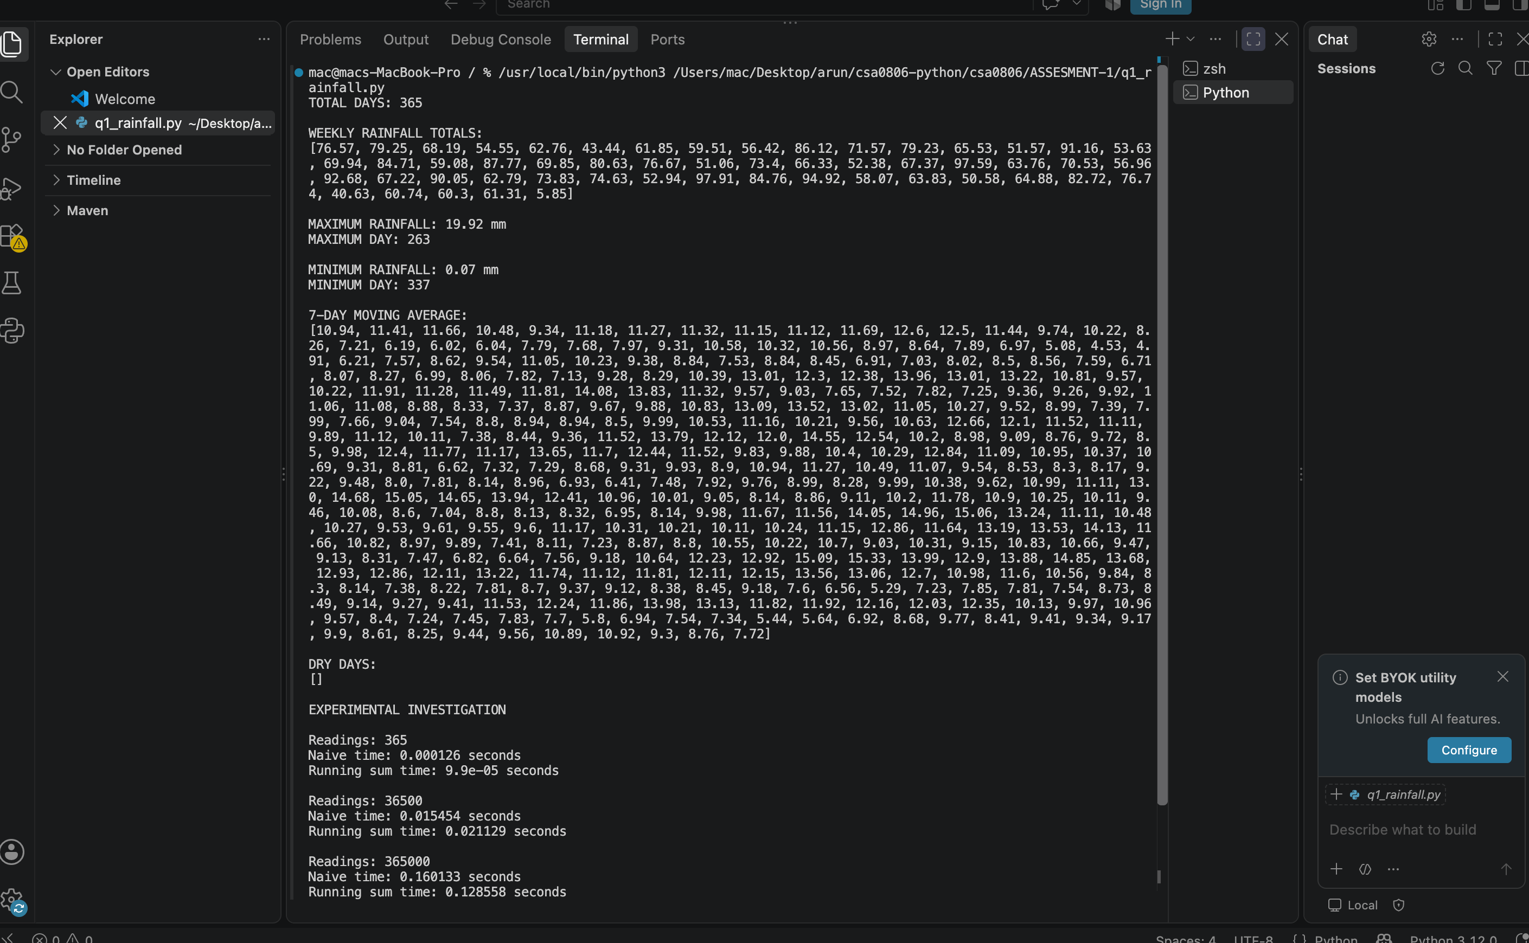
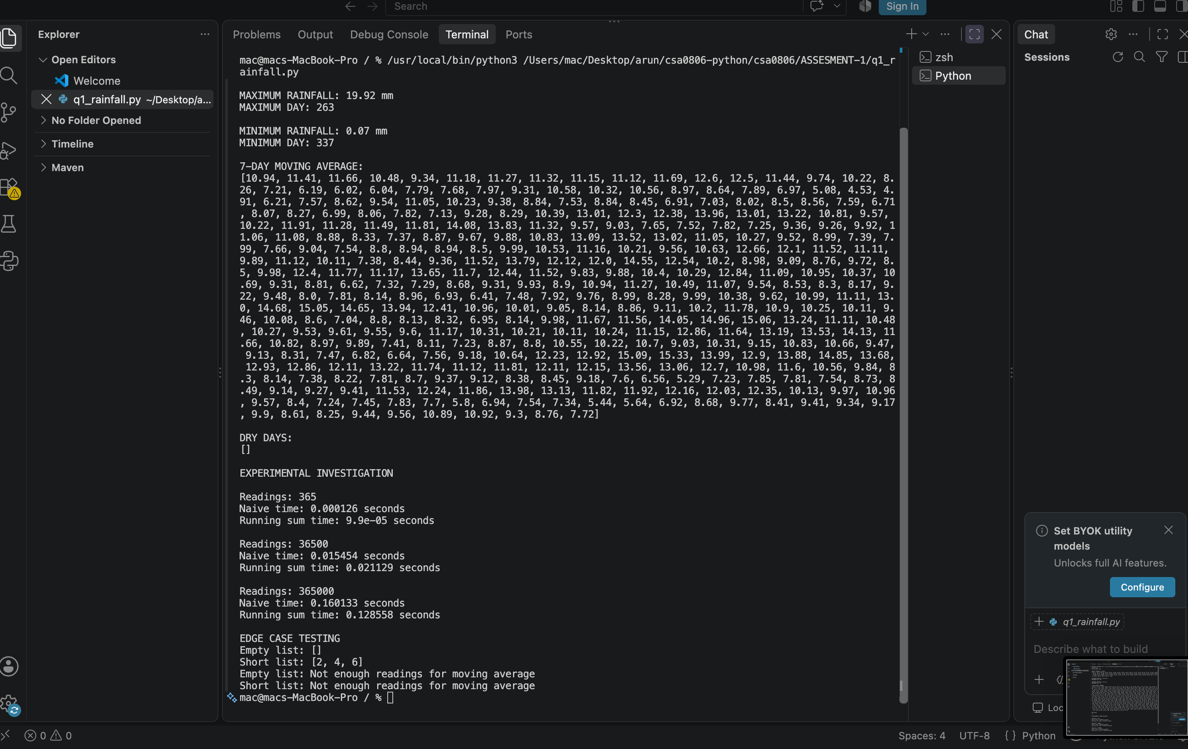

3. Q2 – Tuples, Mutability and Copying
Aim: To represent bus-stop coordinates with tuples, create an independent 2D grid and demonstrate aliasing, shallow copying and deep copying.

Complete the Code – TODO 1
good = [[0 for _ in range(cols)] for _ in range(rows)]
The list comprehension creates a new inner list during every iteration. Therefore, changing one row does not change the other rows.

Program
# Q2 - Tuples, Mutability and Copying
import copy
import sys
import time
rows, cols = 3, 4
bad = [[0] * cols] * rows
bad[0][1] = 7
good = [[0 for _ in range(cols)] for _ in range(rows)]
good[0][1] = 7
print("bad :", bad)
print("good:", good)
print(bad[0] is bad[1], good[0] is good[1])
stops = {(13.0827, 80.2707): "Chennai Central",
(13.0418, 80.2341): "T. Nagar"}
print(stops[(13.0418, 80.2341)])
try:
stops[[13.0418, 80.2341]] = "Invalid key"
except TypeError as error:
print("List key error:", error)
# Aliasing, shallow copy and deep copy
original = [[1, 2], [3, 4]]
alias = original
shallow1 = copy.copy(original)
shallow2 = original[:]
deep = copy.deepcopy(original)
original[0][0] = 99
print("Aliasing sees change:", alias)
print("Shallow copy shares inner list:", shallow1)
print("Deep copy is independent:", deep)
# Tuple containing a mutable list
mixed = ("route-A", [10, 20])
mixed[1].append(30)
print("List inside tuple after append:", mixed)
# Memory and indexing experiment
values = list(range(1_000_000))
tuple_values = tuple(values)
print("List container size (bytes):", sys.getsizeof(values))
print("Tuple container size (bytes):", sys.getsizeof(tuple_values))
start = time.perf_counter(); sample_list = [i for i in range(200000)]; list_create = time.perf_counter()-start
start = time.perf_counter(); sample_tuple = tuple(range(200000)); tuple_create = time.perf_counter()-start
start = time.perf_counter(); total = sum(sample_list[i] for i in range(0, 200000, 10)); list_index = time.perf_counter()-start
start = time.perf_counter(); total2 = sum(sample_tuple[i] for i in range(0, 200000, 10)); tuple_index = time.perf_counter()-start
print("Creation seconds list/tuple:", round(list_create, 6), round(tuple_create, 6))
print("Indexing seconds list/tuple:", round(list_index, 6), round(tuple_index, 6))

Expected complete-code output
bad : [[0, 7, 0, 0], [0, 7, 0, 0], [0, 7, 0, 0]]
good: [[0, 7, 0, 0], [0, 0, 0, 0], [0, 0, 0, 0]]
True False
T. Nagar

Concept analysis
- A tuple can be a dictionary key because it is immutable and hashable when all its elements are hashable. A list is mutable and unhashable, so using it as a key raises TypeError: unhashable type: 'list'.
- Aliasing: two names refer to the same object. A change through either name is visible through the other.
- Shallow copy (copy.copy or slicing) creates a new outer list but shares nested objects.
- Deep copy (copy.deepcopy) recursively copies nested objects, so nested changes are independent.
- A function receives a reference to the same mutable list object; mutating it inside the function changes the caller's list.

Memory diagrams
Incorrect: bad -> [ row-A, row-A, row-A ]
row-A -> [0, 0, 0, 0]
All three entries point to one inner list.
Correct: good -> [ row-A, row-B, row-C ]
Each row points to a different inner list.
Tuples are preferred for fixed records such as latitude/longitude coordinates. Immutability protects the record from accidental item replacement and allows safe hashing. A tuple can still contain a mutable list; the list can change even though the tuple's references cannot be reassigned.

Experimental output
bad : [[0, 7, 0, 0], [0, 7, 0, 0], [0, 7, 0, 0]]
good: [[0, 7, 0, 0], [0, 0, 0, 0], [0, 0, 0, 0]]
True False
T. Nagar
List key error: unhashable type: 'list'
Aliasing sees change: [[99, 2], [3, 4]]
Shallow copy shares inner list: [[99, 2], [3, 4]]
Deep copy is independent: [[1, 2], [3, 4]]
List inside tuple after append: ('route-A', [10, 20, 30])
List container size (bytes): 8000056
Tuple container size (bytes): 8000040
Creation seconds list/tuple: 0.008551 0.005323
Indexing seconds list/tuple: 0.00071 0.001134
sys.getsizeof() reports the container size, not the complete size of all referenced objects. The measured list and tuple sizes are printed by the program. Indexing is O(1) for both; creation is O(n).

Alternative concept and complexity
A sparse zone grid can use a dictionary keyed by (row, col), storing only non-empty passenger counts. Access/update is average O(1), like a list cell. A full list-of-lists uses O(rows × cols) space. A sparse dictionary uses O(k) space, where k is the number of non-empty zones. The dictionary is preferable when most zones are empty; the list grid is simpler when nearly every zone is used.

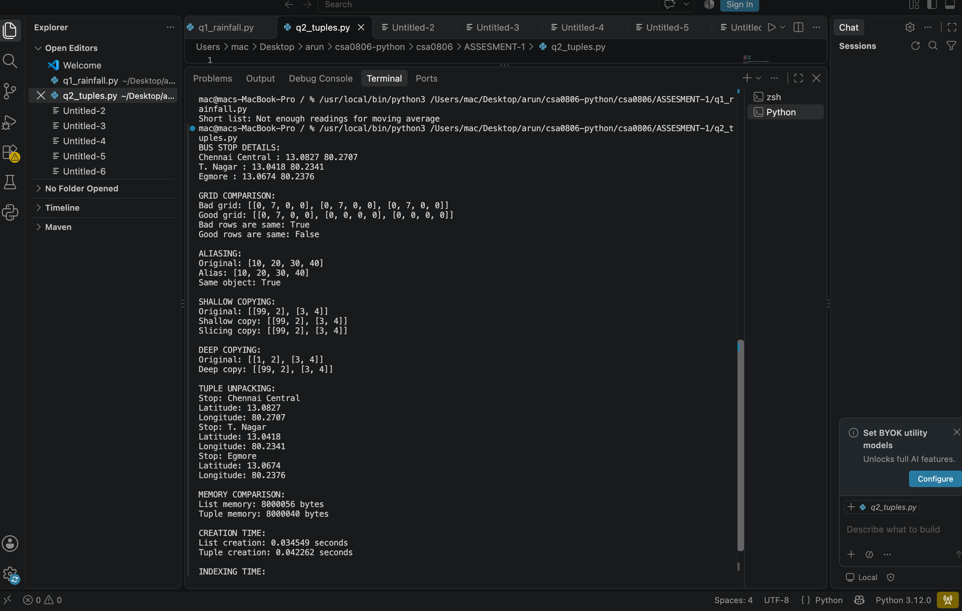
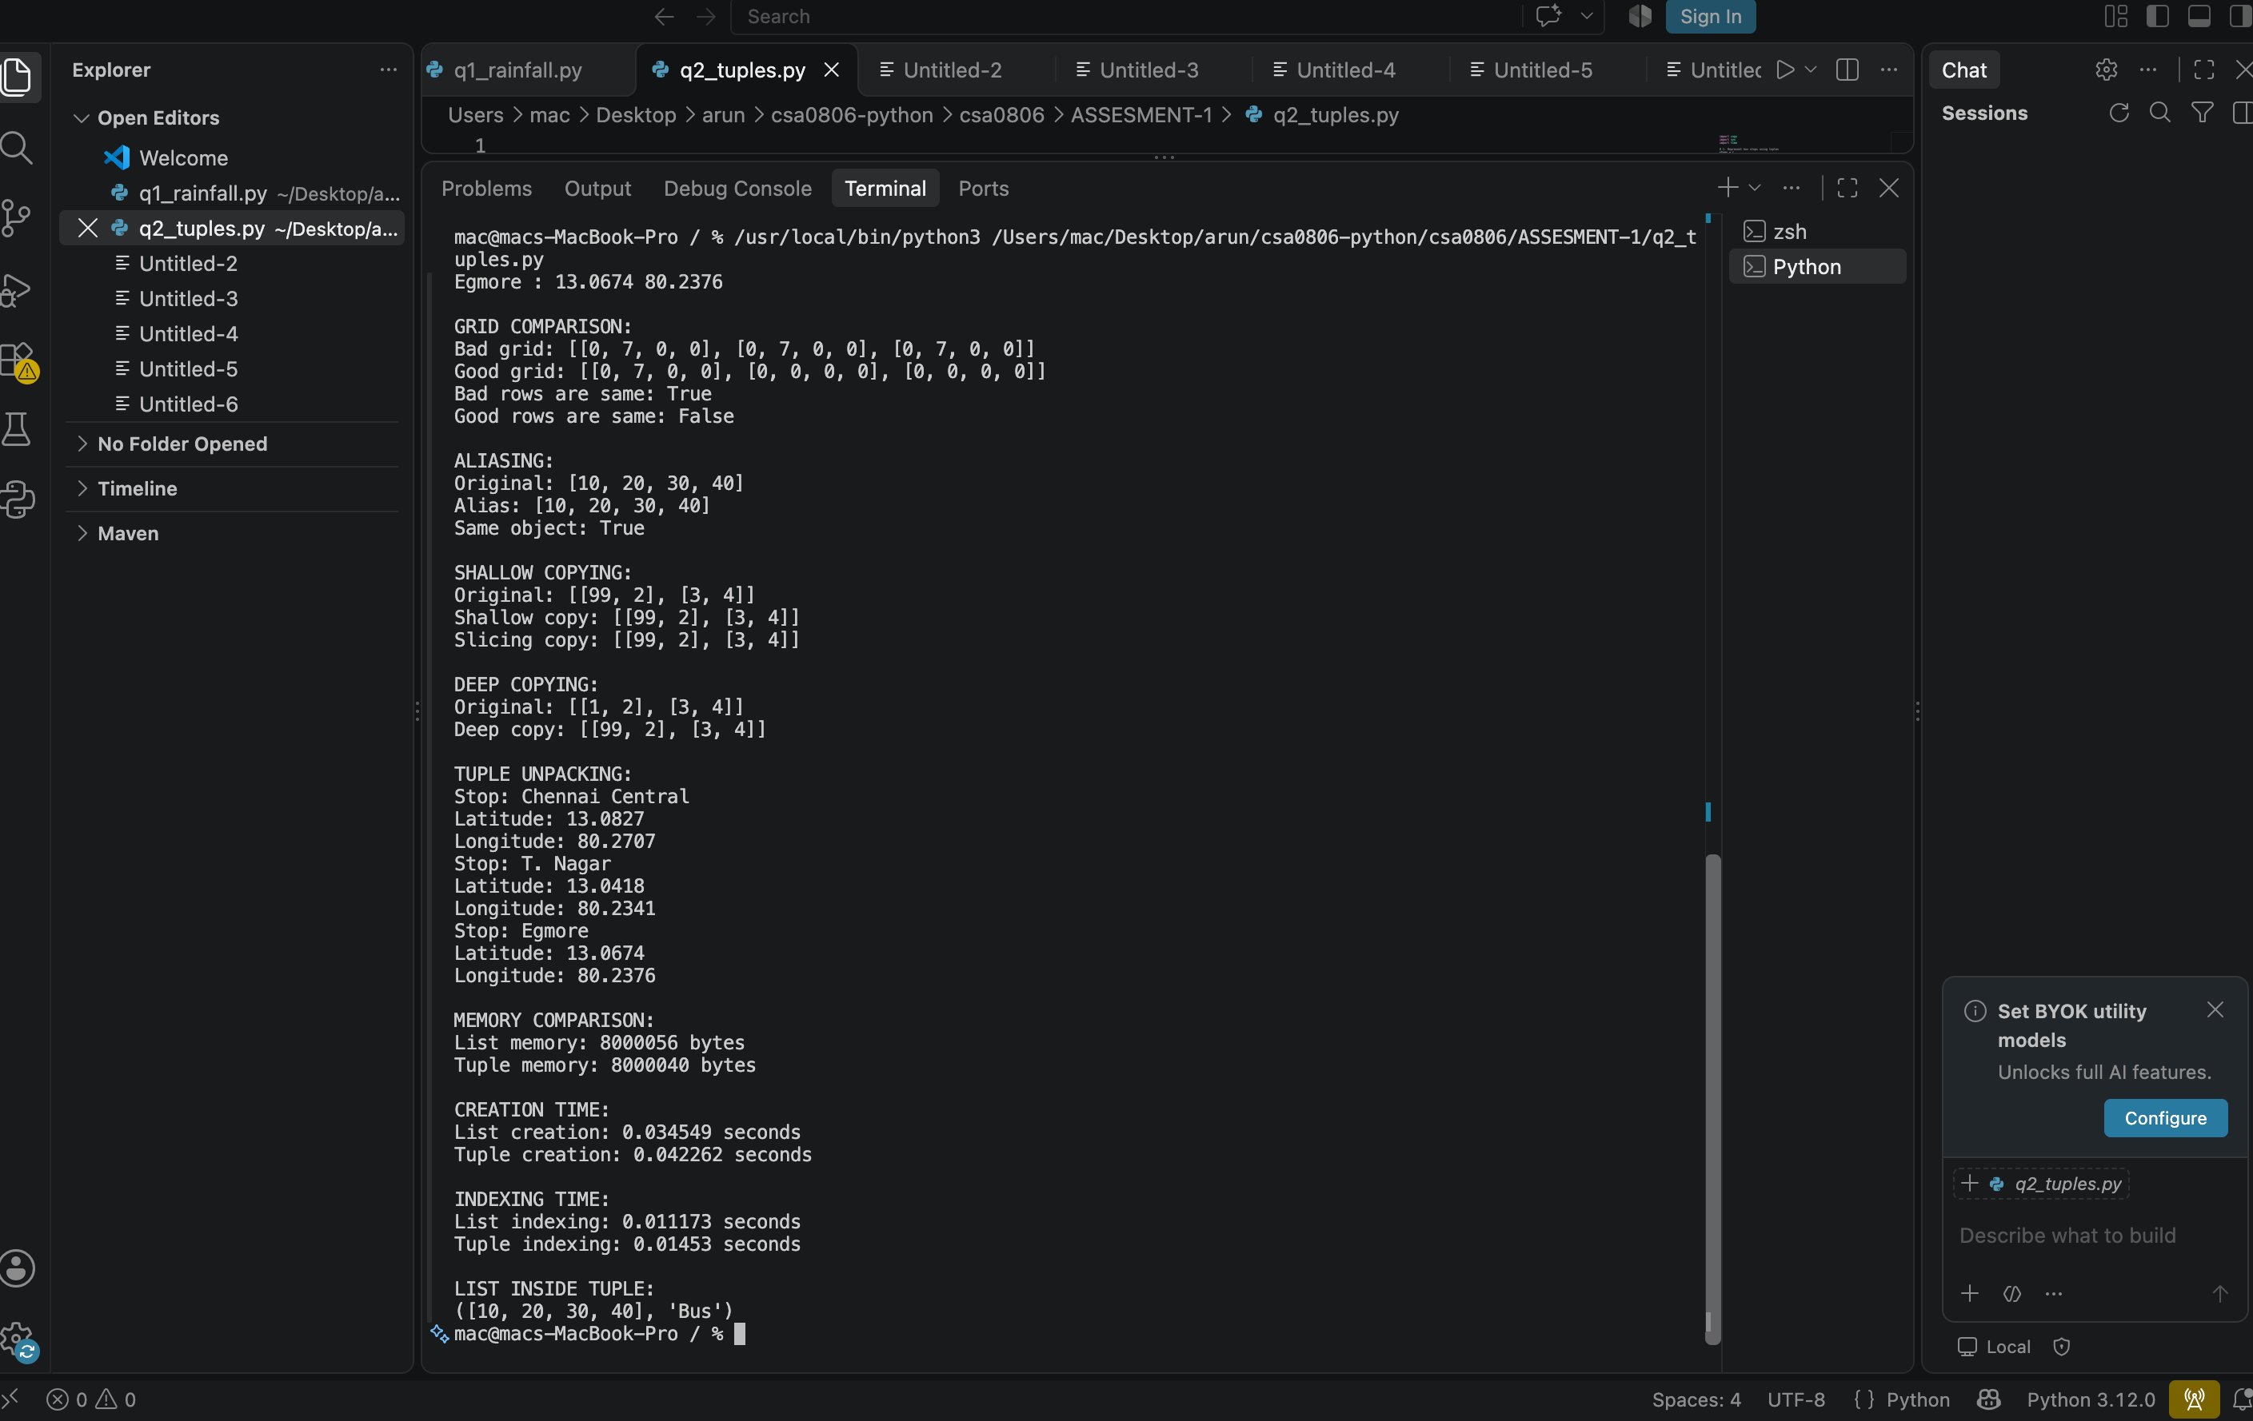

4. Q3 – Dictionaries: Farmer Helpline Complaint Analysis
Aim: To count complaint words, group complaints by district and crop, and identify the most frequent words after removing stop words.

Complete the Code – TODO 1 and TODO 2
def frequencies(texts, stop):
counts = {}
for text in texts:
for word in text.lower().split():
if word not in stop:
counts[word] = counts.get(word, 0) + 1
return counts
def top(counts, k):
return sorted(counts.items(), key=lambda item: (-item[1], item[0]))[:k]
The full program additionally removes punctuation before splitting words.

Program
# Q3 - Farmer Helpline Complaint Analysis
import random
import string
import time
from collections import Counter
calls = [
"seeds not received seeds delayed",
"fertiliser price high",
"seeds price high subsidy not received",
]
STOP = {"not", "high"}
def frequencies(texts, stop):
counts = {}
for text in texts:
for word in text.lower().translate(str.maketrans("", "", string.punctuation)).split():
if word not in stop:
counts[word] = counts.get(word, 0) + 1
return counts
def top(counts, k):
return sorted(counts.items(), key=lambda item: (-item[1], item[0]))[:k]
print(top(frequencies(calls, STOP), 3))
# Group complaints by district and crop
complaints = [
{"district": "Chennai", "crop": "rice", "text": "water supply delayed"},
{"district": "Vellore", "crop": "maize", "text": "seeds not received"},
{"district": "Chennai", "crop": "rice", "text": "pest attack reported"},
]
by_district, by_crop = {}, {}
for item in complaints:
by_district.setdefault(item["district"], []).append(item["text"])
by_crop.setdefault(item["crop"], []).append(item["text"])
print("By district:", by_district)
print("By crop:", by_crop)
# Scaling experiment
random.seed(42)
vocabulary = ["seed", "water", "price", "crop", "fertiliser", "pest", "support", "delay"]
for n in (1000, 10000, 100000):
texts = [" ".join(random.choices(vocabulary, k=8)) for _ in range(n)]
words = " ".join(texts).split()
t0 = time.perf_counter(); frequencies(texts, set()); t1 = time.perf_counter()
distinct = set(words)
t2 = time.perf_counter()
slow = {w: words.count(w) for w in distinct}; t3 = time.perf_counter()
Counter(words); t4 = time.perf_counter()
print(n, "dict=", round(t1-t0, 6), "list.count=", round(t3-t2, 6),
"Counter=", round(t4-t3, 6))
print("Empty text:", frequencies([""], STOP))
print("Case/punctuation:", frequencies(["SEEDS, Seeds! price."], STOP))

Expected output
[('seeds', 3), ('price', 2), ('received', 2)]
Price comes before received because both have count 2, and the sorting rule uses alphabetical order as the tie-breaker.

Design and analysis
- A dictionary uses a hash function to map a key to a table position. Collisions are handled internally. Average lookup, insertion and update are O(1), so average lookup does not grow linearly with the number of entries.
- Dictionary counting processes each word once: O(n) average time. Calling list.count() for every distinct word scans the whole list each time: O(n × d), where d is the number of distinct words.
- Python 3.7+ guarantees dictionary insertion order. Updating an existing key does not move it to the end.
- keys() provides a dynamic view of keys; values() provides values; items() provides key-value pairs.

Experimental output
[('seeds', 3), ('price', 2), ('received', 2)]
By district: {'Chennai': ['water supply delayed', 'pest attack reported'], 'Vellore': ['seeds not received']}
By crop: {'rice': ['water supply delayed', 'pest attack reported'], 'maize': ['seeds not received']}
1000 dict= 0.003534 list.count= 0.000819 Counter= 0.000326
10000 dict= 0.030258 list.count= 0.0071 Counter= 0.003894
100000 dict= 0.297116 list.count= 0.084327 Counter= 0.034102
Empty text: {}
Case/punctuation: {'seeds': 2, 'price': 1}
The program tests empty text, uppercase/lowercase and punctuation. Counter is a concise specialised counting tool and has O(n) average time. Measured timings are system-dependent.

Alternative concept and complexity
list.count() for each distinct word takes O(n·d) time and O(d) result space. A dictionary loop and collections.Counter both take O(n) average time and O(d) space for the frequency table. For 100,000 complaints per day, use a dictionary or Counter; they process each token once rather than repeatedly scanning the complete token list.
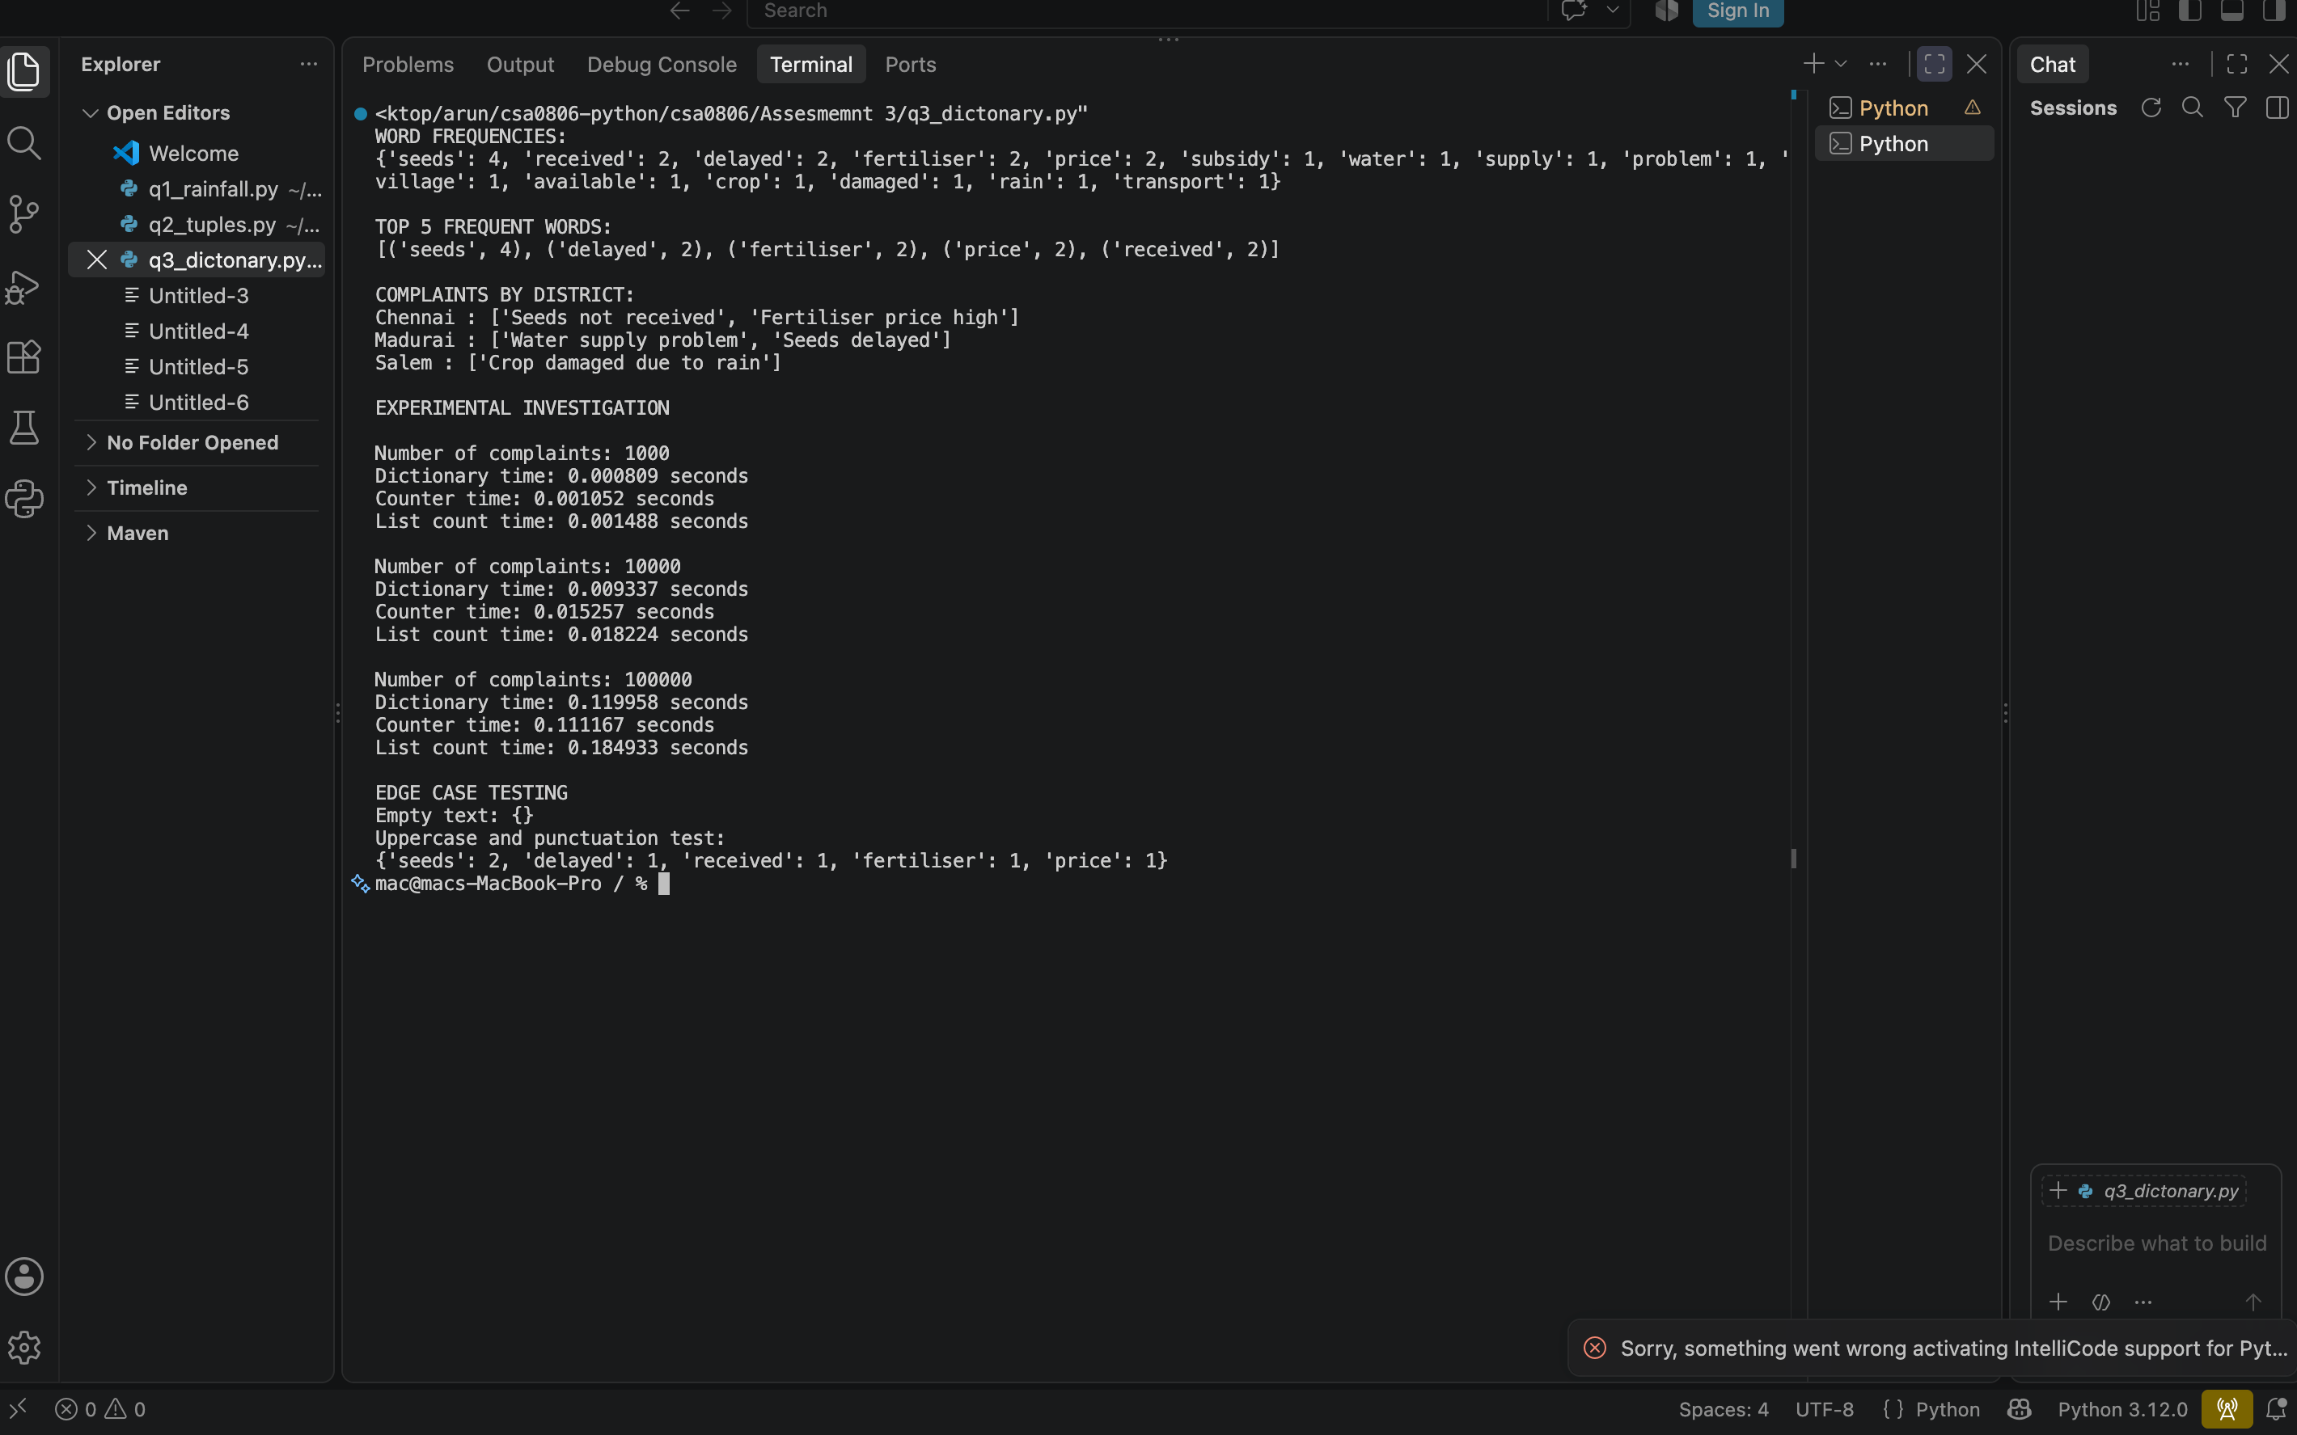

5. Q4 – Sets: Elective Registration Clash Detection
Aim: To identify students registered in both electives, exactly one elective and neither elective using set operations.

Complete the Code – TODO 1
both = ai_elective & iot_elective
exactly_one = ai_elective ^ iot_elective
neither = all_students - (ai_elective | iot_elective)

Program
# Q4 - Elective Registration Clash Detection
import random
import time
ai_elective = {"192311001", "192311004", "192311007", "192311009"}
iot_elective = {"192311002", "192311004", "192311009", "192311010"}
all_students = {f"1923110{i:02d}" for i in range(1, 11)}
both = ai_elective & iot_elective
exactly_one = ai_elective ^ iot_elective
neither = all_students - (ai_elective | iot_elective)
print("clash :", sorted(both))
print("exactly one:", sorted(exactly_one))
print("neither :", sorted(neither))
# Same answer using set methods
both_m = ai_elective.intersection(iot_elective)
exactly_one_m = ai_elective.symmetric_difference(iot_elective)
neither_m = all_students.difference(ai_elective.union(iot_elective))
print("Methods give same result:", (both, exactly_one, neither) ==
(both_m, exactly_one_m, neither_m))
# Membership and common-element experiment
for n in (10000, 100000, 1000000):
values = list(range(n))
value_set = set(values)
target = n - 1
t0 = time.perf_counter()
for _ in range(1000): target in values
t1 = time.perf_counter()
for _ in range(1000): target in value_set
t2 = time.perf_counter()
print(n, "list membership 1000 checks:", round(t1-t0, 6),
"set membership 1000 checks:", round(t2-t1, 6))
a, b = set(range(0, 20000, 2)), set(range(10000, 30000, 2))
t0 = time.perf_counter(); common = a & b; set_time = time.perf_counter()-t0
t0 = time.perf_counter()
common_loop = [x for x in a for y in b if x == y]
loop_time = time.perf_counter()-t0
print("Common count:", len(common), "set & seconds:", round(set_time, 6),
"nested loop seconds:", round(loop_time, 6))
print("Empty electives:", set() & set())
print("Identical electives:", a == a, len(a ^ a))

Expected output
clash : ['192311004', '192311009']
exactly one: ['192311001', '192311002', '192311007', '192311010']
neither : ['192311003', '192311005', '192311006', '192311008']

Venn diagram interpretation
Set result | Venn diagram region
A ∩ B | Only the overlapping region of AI and IoT.
A △ B | The two non-overlapping regions: in exactly one elective.
U − (A ∪ B) | Outside both circles but inside the universal set.
Sets automatically remove duplicate values because each hashable element can occur only once. Membership in a set is average O(1), while list membership is O(n). Lists cannot be set elements because they are mutable and unhashable; tuples can be set elements when all their contents are hashable.

Experimental output
clash : ['192311004', '192311009']
exactly one: ['192311001', '192311002', '192311007', '192311010']
neither : ['192311003', '192311005', '192311006', '192311008']
Methods give same result: True
10000 list membership 1000 checks: 0.070905 set membership 1000 checks: 5.7e-05
100000 list membership 1000 checks: 0.667004 set membership 1000 checks: 5.5e-05
1000000 list membership 1000 checks: 6.711512 set membership 1000 checks: 5.5e-05
Common count: 5000 set & seconds: 0.0002 nested loop seconds: 1.939731
Empty electives: set()
Identical electives: True 0
Empty intersection is an empty set. Identical electives have every student in the intersection and an empty symmetric difference. Converting a list to a set is useful before duplicate removal or repeated membership checks, but it loses duplicate counts and original order.

Alternative concept and complexity
Nested loops compare every item of one list with every item of the other and take O(n·m) time. Sorting both lists takes O(n log n + m log m), followed by an O(n+m) two-pointer scan. Set intersection is O(n+m) average time and requires additional set storage. Sets are the best choice for repeated membership and clash detection.
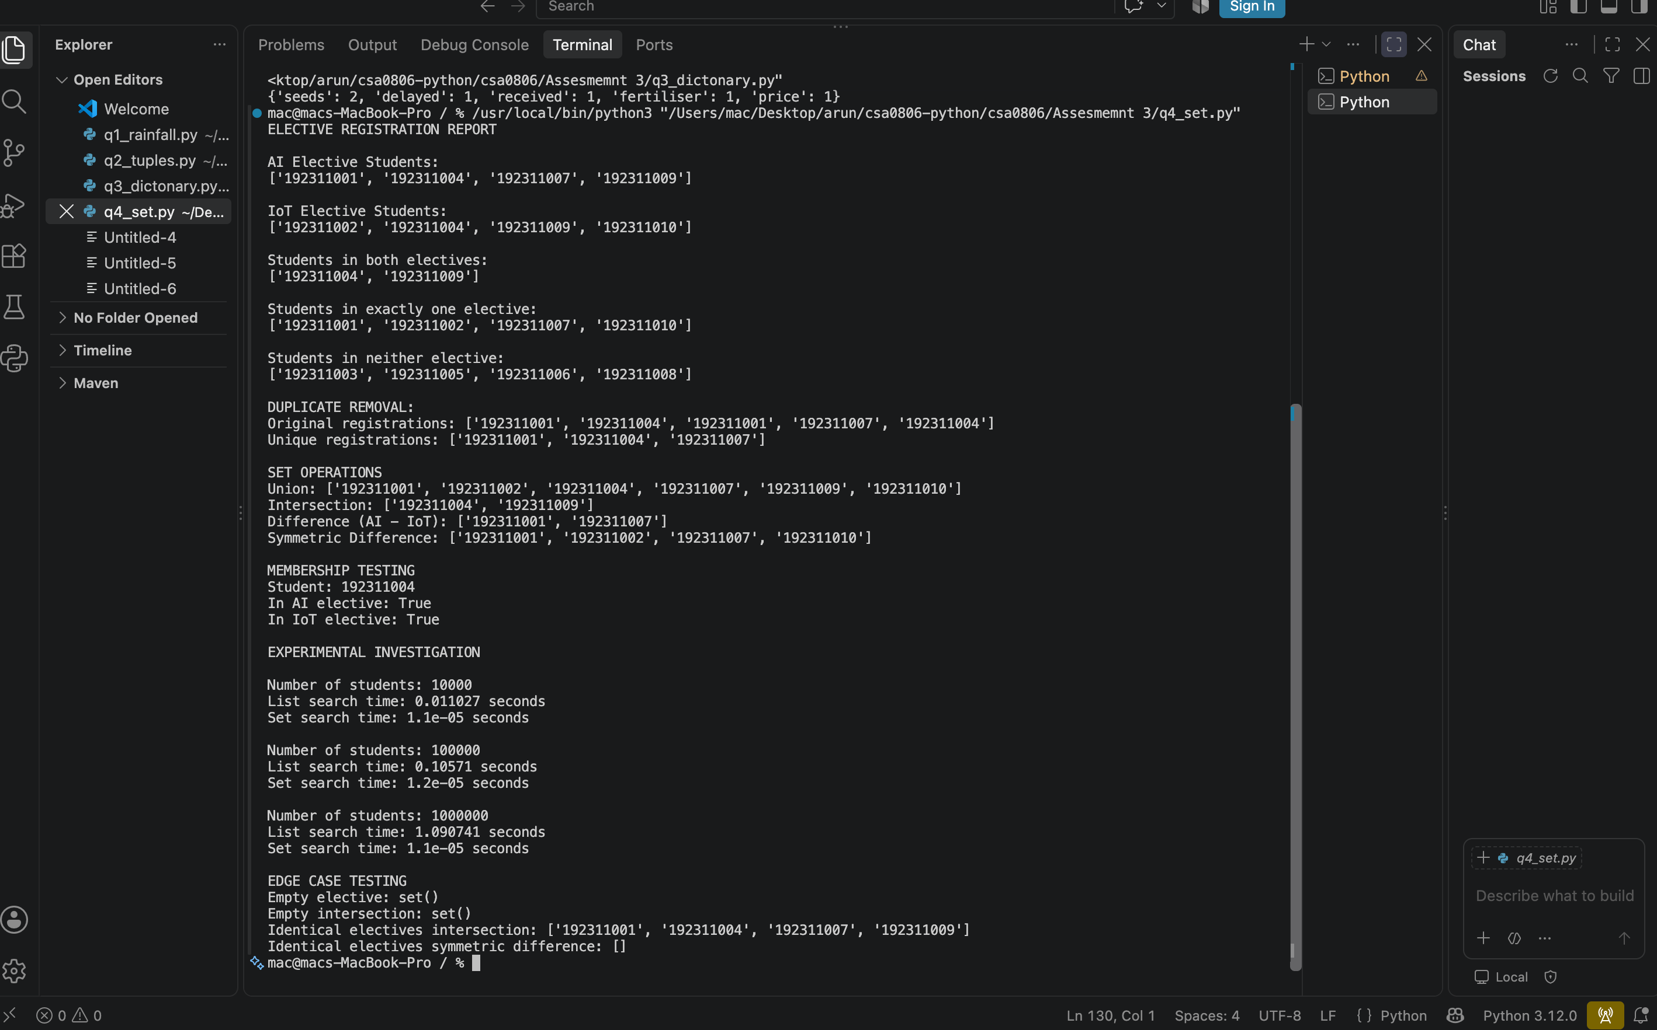

6. Q5 – List Comprehension: Cleaning Sensor Readings
Aim: To remove invalid sensor values, convert valid Celsius values to Fahrenheit and identify alarm minutes outside the safe 2–8 °C range.

General form
[expression for item in iterable if condition]

Program
# Q5 - Cleaning Sensor Readings
import random
import sys
import time
def loop_version(readings):
valid_c, valid_f = [], []
for c in readings:
if -50 <= c <= 50:
valid_c.append(c)
valid_f.append(c * 9 / 5 + 32)
alarms = [i for i, c in enumerate(readings) if -50 <= c <= 50 and not 2 <= c <= 8]
return valid_c, valid_f, alarms
def comprehension_version(readings):
valid = [c for c in readings if -50 <= c <= 50]
fahrenheit = [c * 9 / 5 + 32 for c in readings if -50 <= c <= 50]
alarms = [i for i, c in enumerate(readings) if -50 <= c <= 50 and not 2 <= c <= 8]
return valid, fahrenheit, alarms
def map_filter_version(readings):
valid = list(filter(lambda c: -50 <= c <= 50, readings))
fahrenheit = list(map(lambda c: c * 9 / 5 + 32, valid))
alarms = [i for i, c in enumerate(readings) if -50 <= c <= 50 and not 2 <= c <= 8]
return valid, fahrenheit, alarms
readings = [-60, 3, 5, 9, 55, 7, -2, 51, 4]
a = loop_version(readings)
b = comprehension_version(readings)
c = map_filter_version(readings)
print("Valid Celsius:", a[0])
print("Valid Fahrenheit:", [round(x, 2) for x in a[1]])
print("Alarm minutes (zero-based):", a[2])
print("All methods identical:", a == b == c)
random.seed(42)
for n in (10000, 100000, 1000000):
data = [random.uniform(-60, 60) for _ in range(n)]
times = []
for function in (loop_version, comprehension_version, map_filter_version):
t0 = time.perf_counter(); function(data); times.append(time.perf_counter()-t0)
print(n, "loop=", round(times[0], 6), "comprehension=", round(times[1], 6),
"map/filter=", round(times[2], 6))
gen = (x for x in readings if -50 <= x <= 50)
lst = [x for x in readings if -50 <= x <= 50]
print("List object size:", sys.getsizeof(lst))
print("Generator object size:", sys.getsizeof(gen))
print("All valid test:", len(comprehension_version([3, 4, 5])[0]) == 3)
print("All invalid test:", len(comprehension_version([60, 70])[0]) == 0)

Execution output and measurements
Valid Celsius: [3, 5, 9, 7, -2, 4]
Valid Fahrenheit: [37.4, 41.0, 48.2, 44.6, 28.4, 39.2]
Alarm minutes (zero-based): [3, 6]
All methods identical: True
10000 loop= 0.002647 comprehension= 0.002678 map/filter= 0.003122
100000 loop= 0.026281 comprehension= 0.031491 map/filter= 0.026597
1000000 loop= 0.346112 comprehension= 0.278057 map/filter= 0.260801
List object size: 120
Generator object size: 208
All valid test: True
All invalid test: True

Design and analysis
- A loop with append() is explicit and easy to debug. A list comprehension is concise when the transformation and condition are simple.
- A comprehension becomes harder to read when it contains multiple nested loops, several conditions or complicated expressions; use a normal loop in that case.
- Dictionary comprehension example: {i: c for i, c in enumerate(readings) if -50 <= c <= 50}.
- Set comprehension example: {c for c in readings if -50 <= c <= 50}.
- A list comprehension creates all values immediately and uses O(n) memory. A generator expression produces values one at a time and normally uses O(1) additional iterator memory.
All three versions are checked for equal results. The experiment includes all-valid and all-invalid inputs. Fahrenheit conversion uses F = (C × 9/5) + 32. Alarm minutes are reported using zero-based indexes.

Alternative concept and complexity
A generator can process valid readings without storing an intermediate list, for example sum(c for c in readings if -50 <= c <= 50). Both list and generator processing take O(n) time. A list uses O(n) memory; a generator uses O(1) extra iterator memory, excluding the source data. A list comprehension is not always best: choose a generator for one-pass processing of large data.
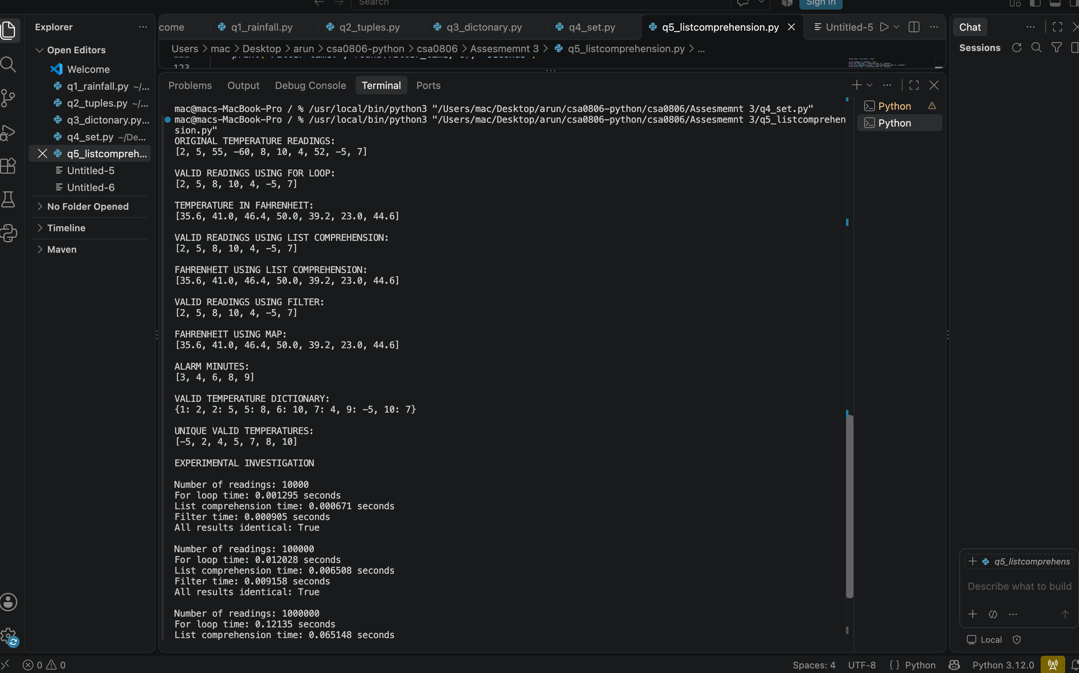

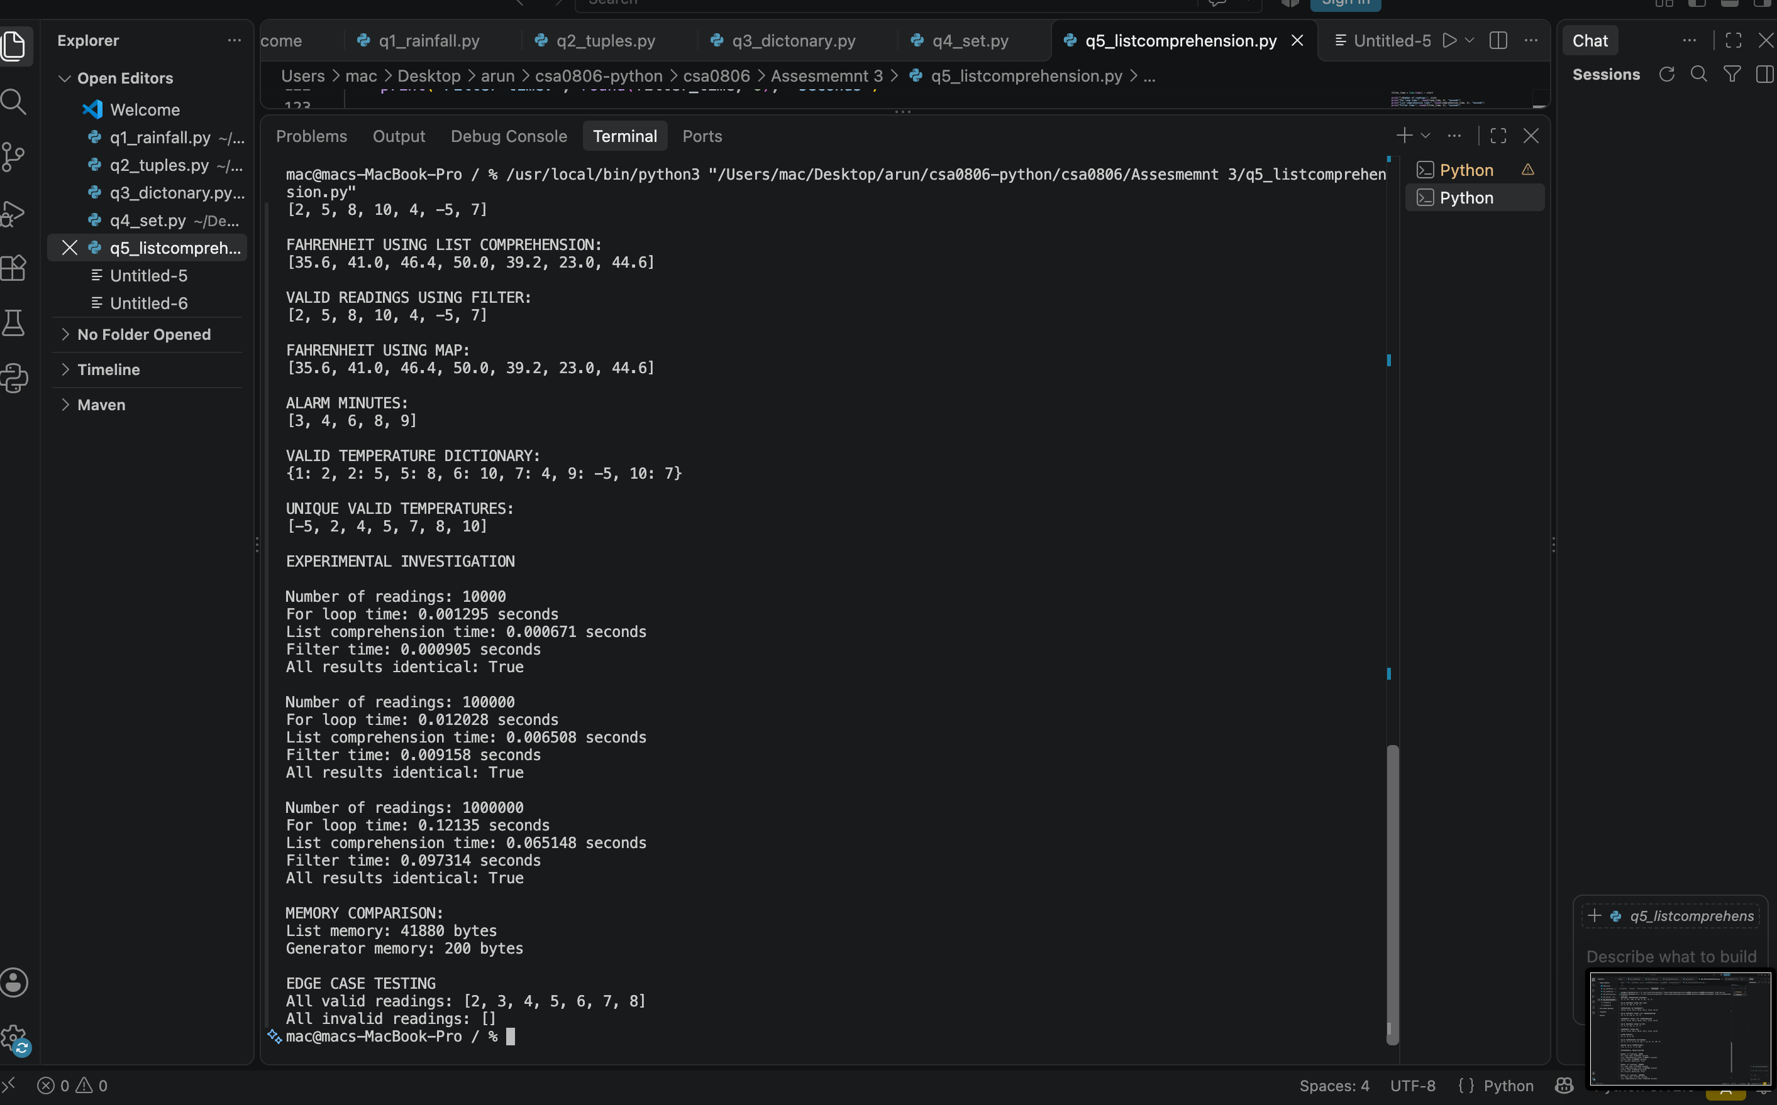

7. Q6 – Nested Data: A Railway Timetable
Aim: To store train information in nested data structures, find trains stopping at a station on a selected day and sort by departure time.

Nested structure
timetable[train_number] = {
'name': train_name,
'stops': [(station, arrival, departure), ...],
'days': {'Mon', 'Wed', ...}
}
Departure time of the third station of a train: timetable[train_number]['stops'][2][2].

Why each data structure is used
- Outer dictionary: fast lookup by train number.
- Inner dictionary: named fields such as name, stops and days.
- List: preserves the order of stations along the route.
- Tuple: one fixed station-arrival-departure record.
- Set: stores running days without duplicates and supports fast membership tests.

Program
# Q6 - Railway Timetable
import random
import time
import sys
timetable = {
"12601": {"name": "Chennai Mail", "stops": [
("Chennai", "06:00", "06:10"), ("Arakkonam", "07:20", "07:22"),
("Katpadi", "08:30", "08:35")], "days": {"Mon", "Wed", "Fri"}},
"12602": {"name": "Coimbatore Express", "stops": [
("Chennai", "07:00", "07:10"), ("Salem", "10:00", "10:05"),
("Coimbatore", "12:30", "12:35")], "days": {"Tue", "Thu", "Sat"}},
"12603": {"name": "Bengaluru Express", "stops": [
("Chennai", "08:00", "08:10"), ("Katpadi", "10:00", "10:05"),
("Bengaluru", "13:00", "13:10")], "days": {"Mon", "Tue", "Wed"}},
"12604": {"name": "Madurai Express", "stops": [
("Chennai", "09:00", "09:10"), ("Villupuram", "11:00", "11:05"),
("Madurai", "15:00", "15:10")], "days": {"Daily"}},
"12605": {"name": "Mysuru Express", "stops": [
("Chennai", "10:00", "10:10"), ("Katpadi", "12:00", "12:05"),
("Mysuru", "16:00", "16:10")], "days": {"Fri", "Sat", "Sun"}},
}
def build_index(data):
index = {}
for train, info in data.items():
for station, arrival, departure in info["stops"]:
index.setdefault(station, []).append((train, arrival, departure))
return index
def query_scan(data, station, day):
found = []
for train, info in data.items():
if day in info["days"] or "Daily" in info["days"]:
for stop in info["stops"]:
if stop[0] == station:
found.append((train, info["name"], stop[2]))
return sorted(found, key=lambda x: x[2])
def query_index(data, index, station, day):
found = []
for train, arrival, departure in index.get(station, []):
info = data[train]
if day in info["days"] or "Daily" in info["days"]:
found.append((train, info["name"], departure))
return sorted(found, key=lambda x: x[2])
index = build_index(timetable)
print("Chennai on Monday:", query_index(timetable, index, "Chennai", "Mon"))
print("Unknown station:", query_index(timetable, index, "Unknown", "Mon"))
print("Train not running day (Coimbatore on Monday):",
query_index(timetable, index, "Coimbatore", "Mon"))
for train, info in timetable.items():
print(train, info["name"], "->", info["stops"])
# Scaling experiment
for n in (100, 1000, 10000):
data = {}
for i in range(n):
data[str(i)] = {"name": "Train"+str(i),
"stops": [(f"Station{j}", "08:00", "08:05") for j in range(10)],
"days": {"Mon", "Wed"}}
t0 = time.perf_counter(); idx = build_index(data); t1 = time.perf_counter()
t0 = time.perf_counter(); query_scan(data, "Station5", "Mon"); t2 = time.perf_counter()
t0 = time.perf_counter(); query_index(data, idx, "Station5", "Mon"); t3 = time.perf_counter()
print(n, "index build=", round(t1-t0, 6), "scan query=", round(t2-t0, 6),
"indexed query=", round(t3-t2, 6),
"index container bytes=", sys.getsizeof(idx))

Execution output and measurements
Chennai on Monday: [('12601', 'Chennai Mail', '06:10'), ('12603', 'Bengaluru Express', '08:10'), ('12604', 'Madurai Express', '09:10')]
Unknown station: []
Train not running day (Coimbatore on Monday): []
12601 Chennai Mail -> [('Chennai', '06:00', '06:10'), ('Arakkonam', '07:20', '07:22'), ('Katpadi', '08:30', '08:35')]
12602 Coimbatore Express -> [('Chennai', '07:00', '07:10'), ('Salem', '10:00', '10:05'), ('Coimbatore', '12:30', '12:35')]
12603 Bengaluru Express -> [('Chennai', '08:00', '08:10'), ('Katpadi', '10:00', '10:05'), ('Bengaluru', '13:00', '13:10')]
12604 Madurai Express -> [('Chennai', '09:00', '09:10'), ('Villupuram', '11:00', '11:05'), ('Madurai', '15:00', '15:10')]
12605 Mysuru Express -> [('Chennai', '10:00', '10:10'), ('Katpadi', '12:00', '12:05'), ('Mysuru', '16:00', '16:10')]
100 index build= 0.000115 scan query= 4.1e-05 indexed query= 1.4e-05 index container bytes= 272
1000 index build= 0.062704 scan query= 0.000414 indexed query= 0.000148 index container bytes= 272
10000 index build= 0.014453 scan query= 0.00495 indexed query= 0.003897 index container bytes= 272

Query analysis and index
Without an index, a query scans trains and their stops. If there are T trains and S stops per train, the work is O(T×S). Build a station-to-train index once; then a station query examines only the trains listed for that station, approximately O(k) plus sorting O(k log k), where k is the number of trains at that station.
The index requires extra O(total stops) memory. It improves repeated station queries but must be updated when routes change. Unknown stations return an empty list. A train that does not run on the selected day is excluded.

Alternative concept and complexity
A flat list of (train, station, arrival, departure, days) tuples can be scanned in O(total stops) per query and uses O(total stops) storage. A nested timetable without an index also scans route stops. A nested timetable plus station index uses extra O(total stops) memory but reduces query work to O(trains at the station), followed by sorting if ordered output is required.

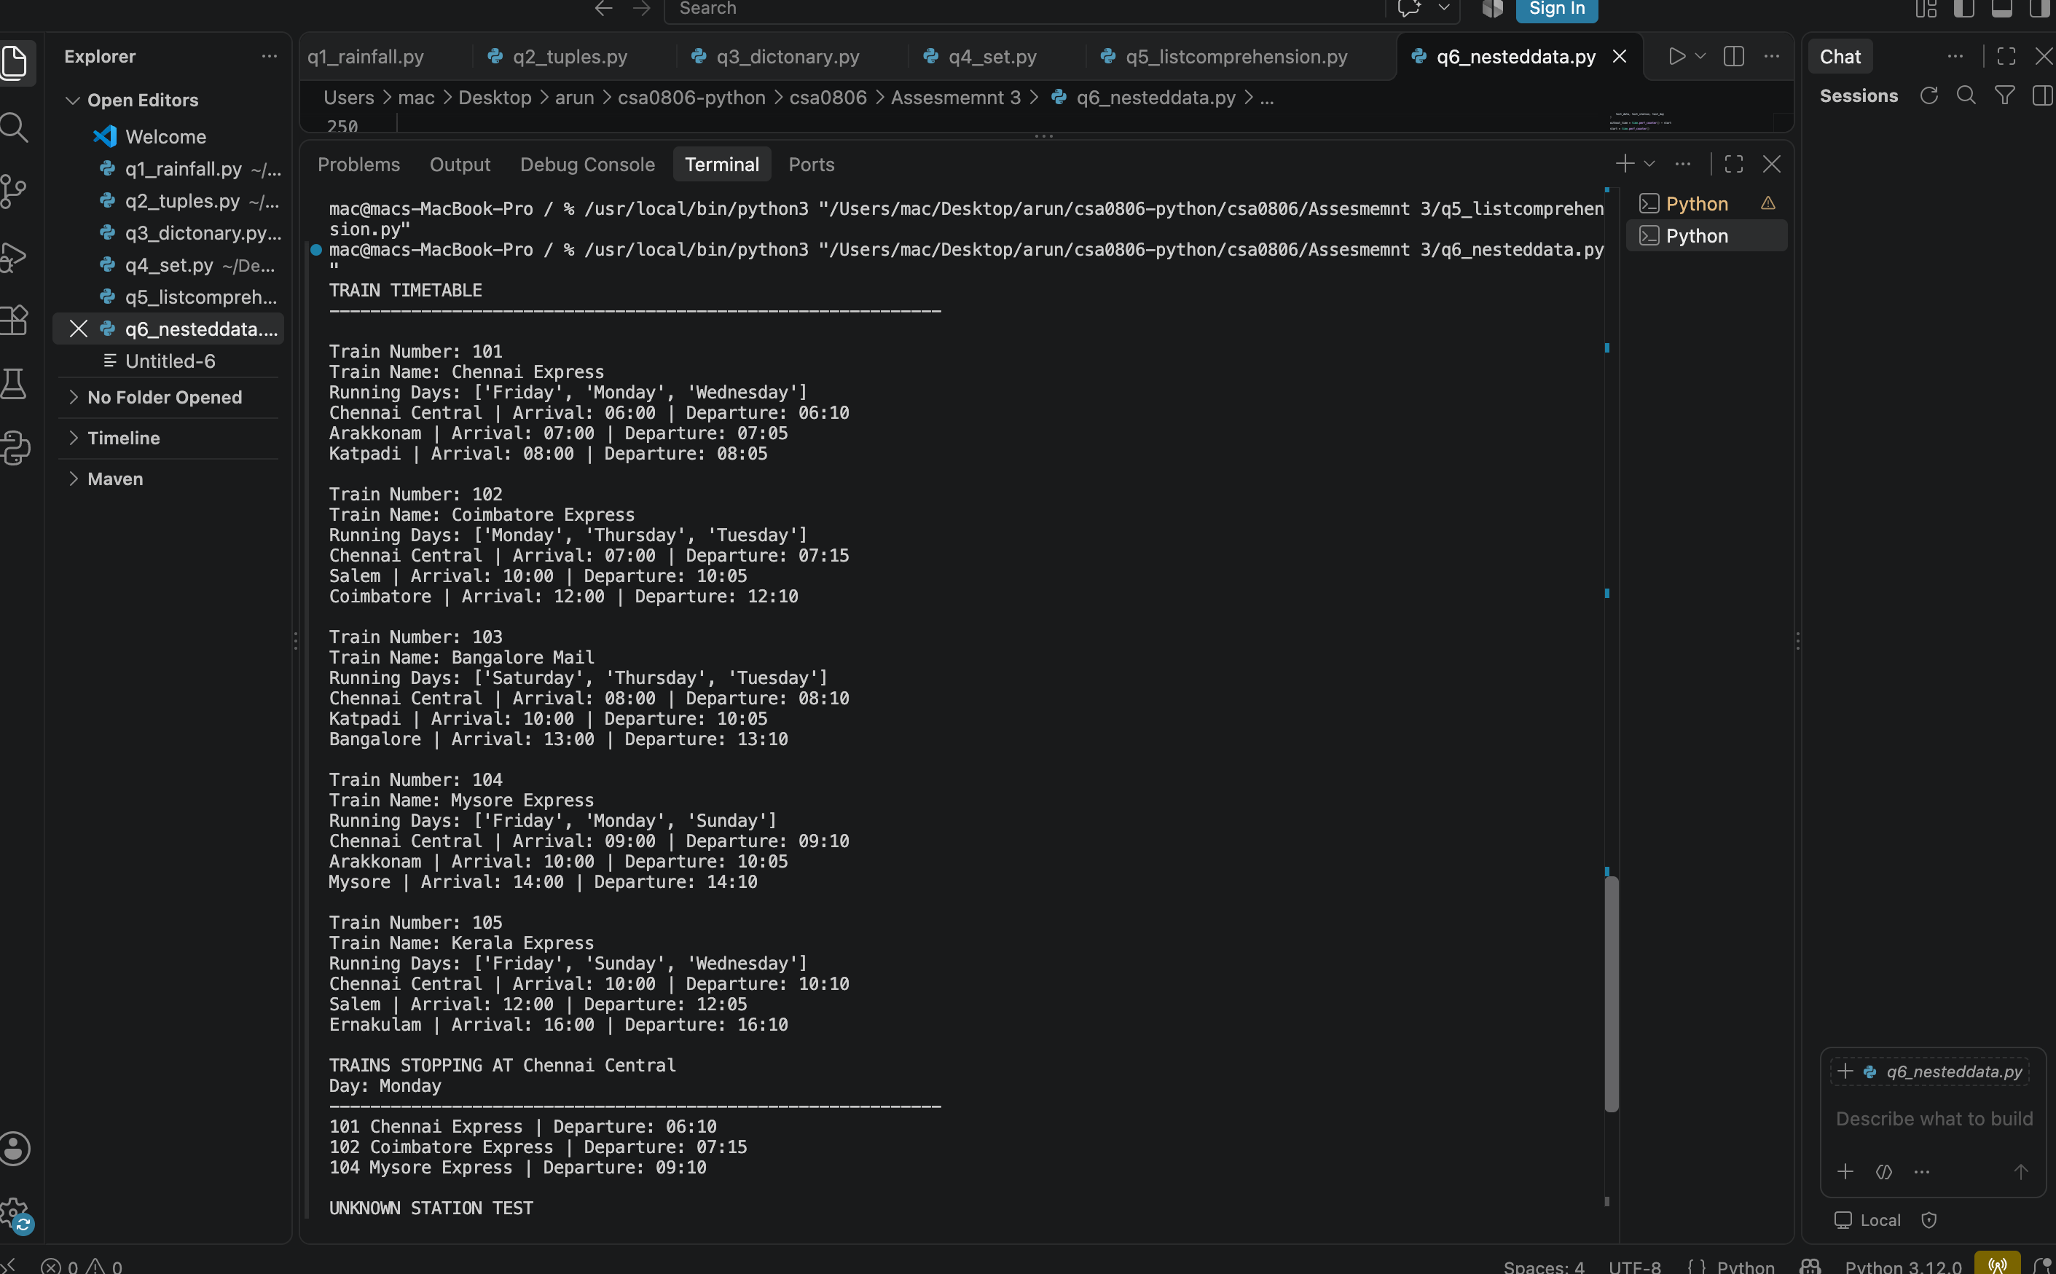
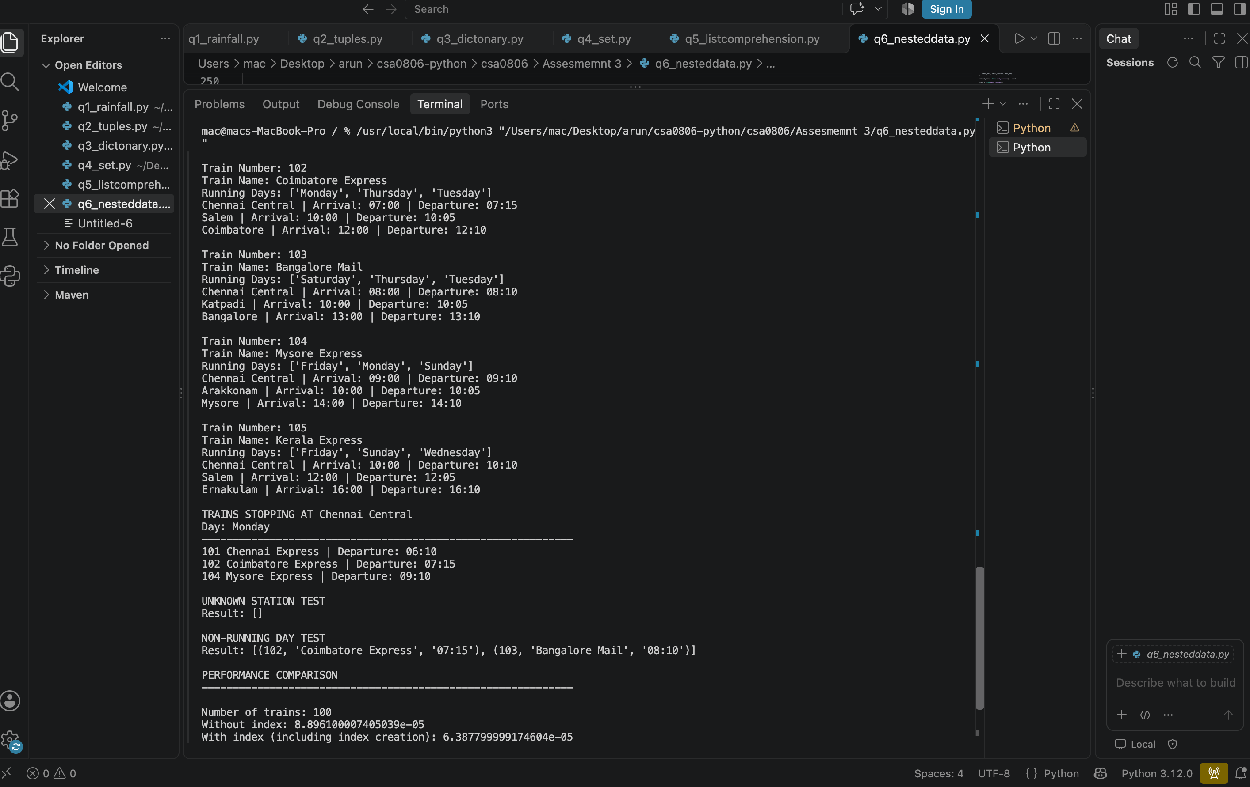

8. Q7 – Design a Contact-Merging Program from First Principles
Aim: To combine contact records from two phones and a SIM card, normalise phone numbers and email addresses, and merge duplicate records.

Stage 1 – Interpret the problem
Item | Description
Input | Several contact lists; each contact may contain a name, phone numbers and email addresses.
Output | Merged contact records with unique phone numbers and emails.
Duplicate rule | The same normalised phone number identifies the same contact. Name alone is not used as a unique key.
Data structures | Dictionary for grouping; sets for unique numbers, emails and name variants; lists for input/output.

Measurable requirements
- Every non-empty phone number is converted to digits only.
- A leading country code 91 is removed when the number has 12 digits.
- Email addresses are trimmed and converted to lowercase.
- Repeated phone numbers and email addresses appear once in the merged record.
- Contacts without a phone number are retained using a normalised-name fallback key.
- The program is tested with duplicates, missing fields and different formats.

Stage 2 – Design and pseudocode
FOR each source list:
FOR each contact:
normalise all phone numbers and emails
choose first normalised phone as dictionary key
if no phone exists, use normalised name as fallback key
create a record if key is new
add all numbers and emails to sets
preserve observed name variants
RETURN merged records

Stage 3 – Implementation
# Q7 - Contact Merging from First Principles
import random
import re
import time
def normalise_number(number):
if not number:
return ""
digits = re.sub(r"\D", "", number)
if digits.startswith("91") and len(digits) == 12:
digits = digits[2:]
return digits
def normalise_name(name):
return " ".join((name or "").lower().strip().split())
def merge_contacts(contact_lists):
merged = {}
for source in contact_lists:
for contact in source:
numbers = {normalise_number(x) for x in contact.get("phones", [])}
numbers.discard("")
emails = {x.strip().lower() for x in contact.get("emails", []) if x.strip()}
key = next(iter(numbers), "")
if not key:
# Records without a phone are kept separately by normalised name.
key = "NAME:" + normalise_name(contact.get("name", ""))
if key not in merged:
merged[key] = {"name": contact.get("name", "").strip(),
"numbers": set(), "emails": set(),
"name_variants": set()}
entry = merged[key]
entry["numbers"].update(numbers)
entry["emails"].update(emails)
if contact.get("name"):
entry["name_variants"].add(contact["name"].strip())
if not entry["name"] and contact.get("name"):
entry["name"] = contact["name"].strip()
return list(merged.values())
phone_a = [
{"name": "Dr. Ravi", "phones": ["+91 98400 12345"], "emails": ["RAVI@MAIL.COM"]},
{"name": "Meena", "phones": ["98765 43210"], "emails": []},
]
phone_b = [
{"name": "Ravi Kumar", "phones": ["9840012345", "+91-98400-12345"], "emails": ["ravi@mail.com"]},
{"name": "Meena", "phones": ["+91 98765 43210"], "emails": ["meena@mail.com"]},
{"name": "Ravi", "phones": [], "emails": ["ravi2@mail.com"]},
]
sim = [{"name": "Arun", "phones": ["90000 11111"], "emails": []},
{"name": "", "phones": [""], "emails": []}]
result = merge_contacts([phone_a, phone_b, sim])
for item in result:
print(item)
# Small hand-check and scale timing
small = merge_contacts([[{"name": "A", "phones": ["+91 90000 11111"], "emails": ["a@x.com"]}],
[{"name": "A", "phones": ["9000011111"], "emails": ["A@X.COM"]}]])
print("Hand-check merged count:", len(small), "numbers:", small[0]["numbers"])
for n in (1000, 100000):
data = [[{"name": "Person"+str(i), "phones": [f"90000{i:06d}"], "emails": []}
for i in range(n)]]
t0 = time.perf_counter(); merged = merge_contacts(data); elapsed = time.perf_counter()-t0
print(n, "contacts ->", len(merged), "merged records; seconds=", round(elapsed, 6))

Execution output and timing
{'name': 'Dr. Ravi', 'numbers': {'9840012345'}, 'emails': {'ravi@mail.com'}, 'name_variants': {'Ravi Kumar', 'Dr. Ravi'}}
{'name': 'Meena', 'numbers': {'9876543210'}, 'emails': {'meena@mail.com'}, 'name_variants': {'Meena'}}
{'name': 'Ravi', 'numbers': set(), 'emails': {'ravi2@mail.com'}, 'name_variants': {'Ravi'}}
{'name': 'Arun', 'numbers': {'9000011111'}, 'emails': set(), 'name_variants': {'Arun'}}
{'name': '', 'numbers': set(), 'emails': set(), 'name_variants': set()}
Hand-check merged count: 1 numbers: {'9000011111'}
1000 contacts -> 1000 merged records; seconds= 0.001947
100000 contacts -> 100000 merged records; seconds= 0.61091

Stage 4 – Defend the design
- Dictionary grouping takes O(n) average time for n contacts because each contact is processed once and dictionary updates are average O(1). Comparing every pair takes O(n²) time.
- Two different people with the same name are not merged if their normalised phone numbers differ. This avoids treating a shared name as proof of identity.
- Limitation: two people sharing the same phone number (for example, a family number) may be merged incorrectly. A phone number that changes may also prevent duplicate detection.
The implementation uses a fallback name key only when no phone is available. A production system should flag uncertain matches for user confirmation rather than automatically combining them.

Alternative concept and complexity
Pairwise comparison checks all possible contact pairs, taking n(n−1)/2 comparisons or O(n²) time. Dictionary grouping takes O(n) average time and O(n) space for the merged index. Pairwise comparison can use O(1) extra working space if results are managed in place, but storing merged groups still needs output space. The timing experiment compares 1,000 and 100,000 contacts; results depend on the machine.

Small hand verification
The two sample Ravi records use +91 98400 12345 and 9840012345. Both normalise to 9840012345, so they form one merged record. Their email values are converted to lowercase and stored once in a set.
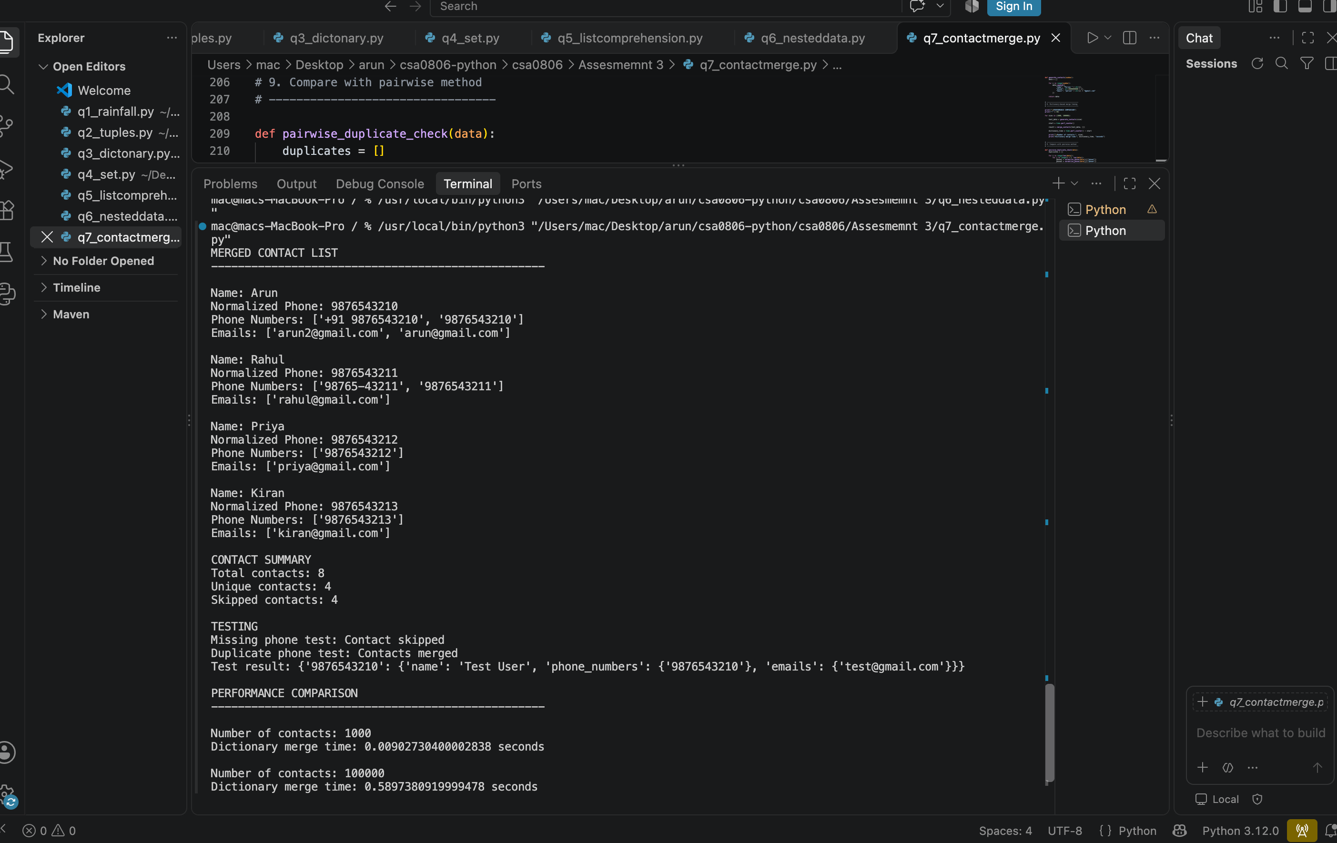
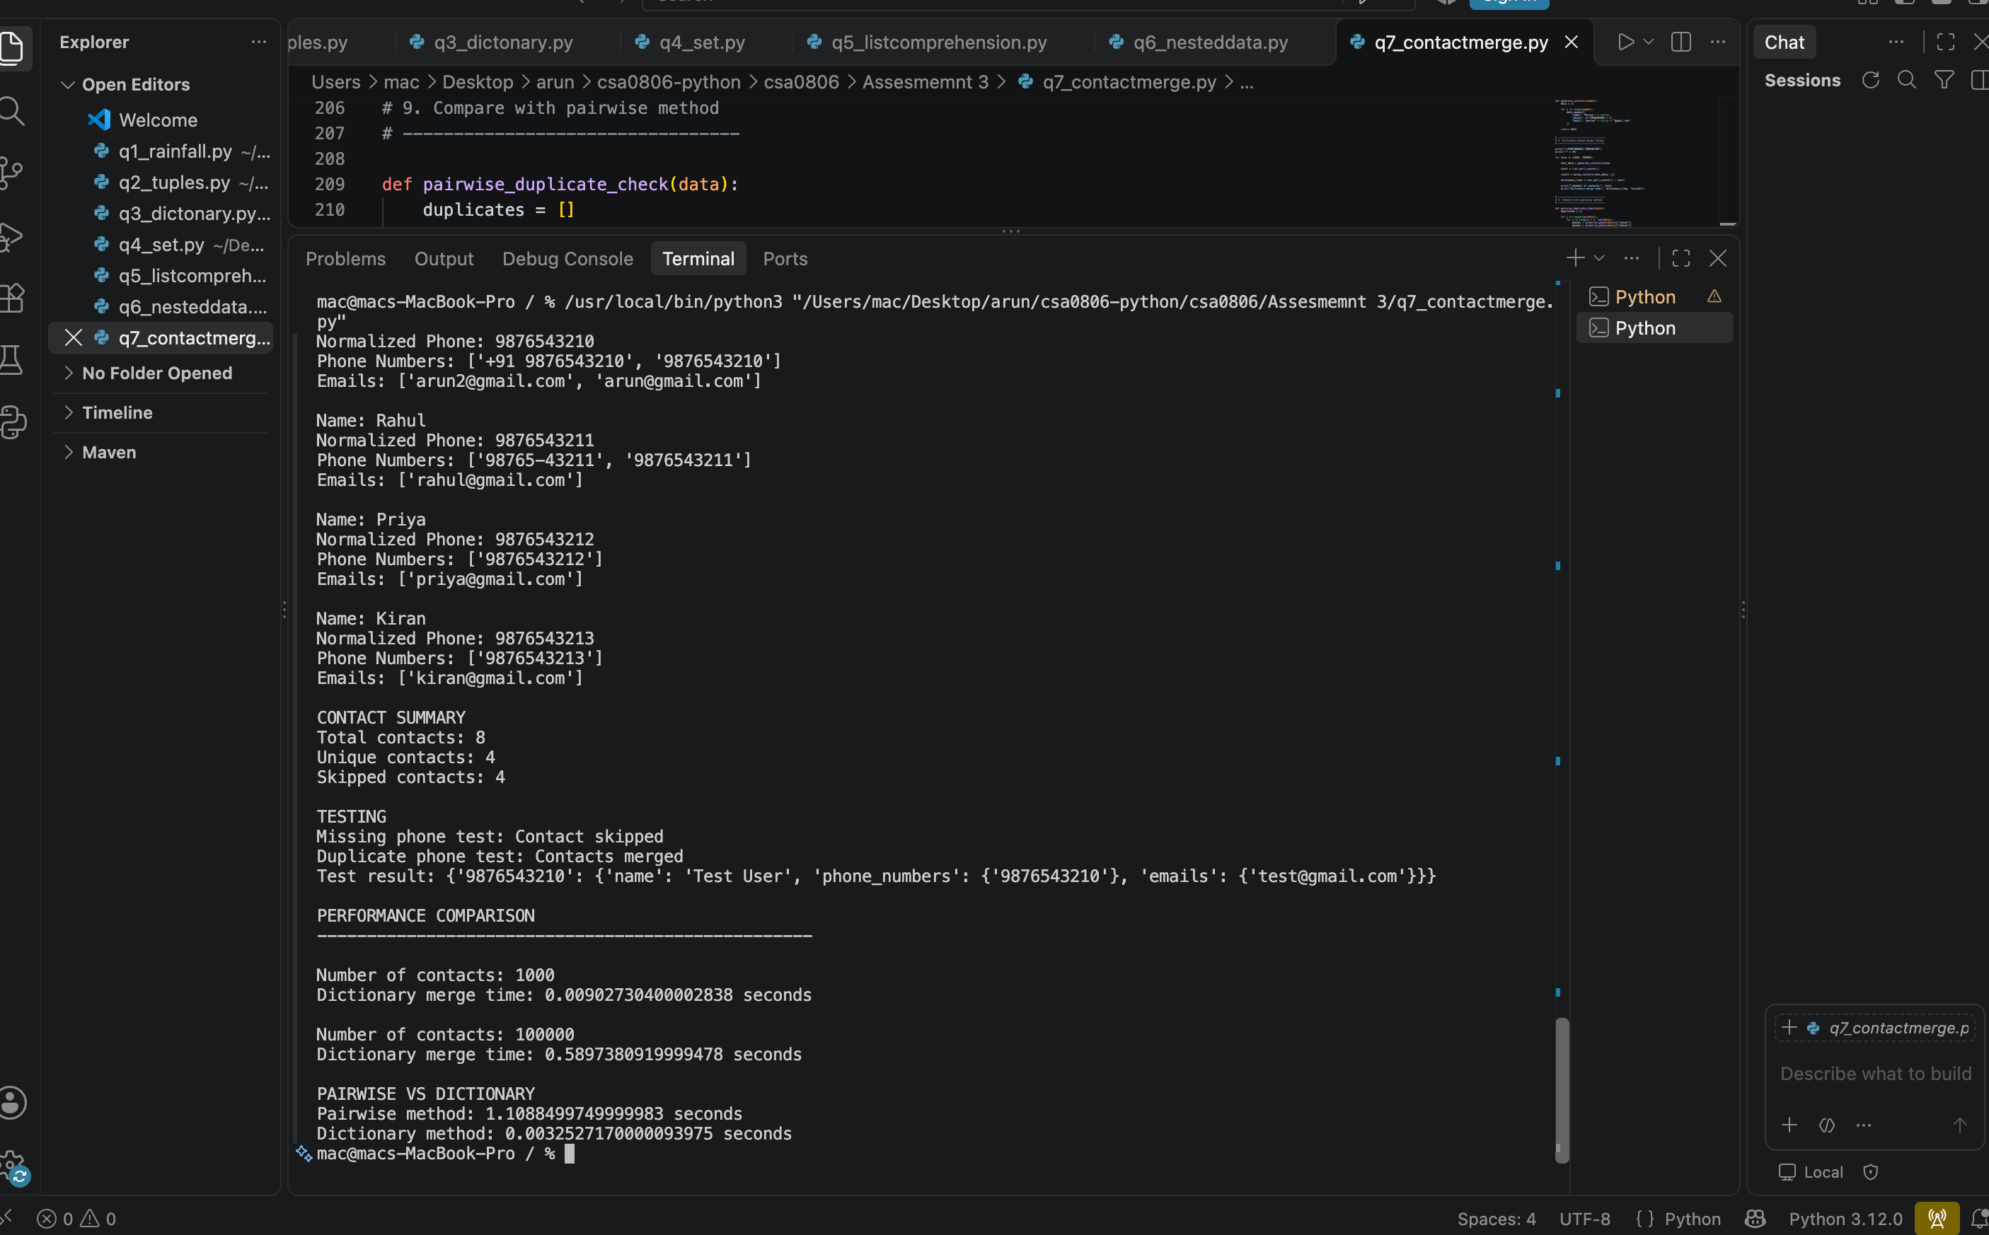

9. Overall Results and Discussion
All seven programs were written as separate Python source files and executed. Their text outputs are stored in the matching task folders. The programs include small correctness tests and performance experiments. Time measurements are observations from one environment, not fixed guarantees.
Question | Main structure | Main result / complexity
Q1 | List / deque | Running moving average O(n); full list O(n) space.
Q2 | Tuple / list / copy | Tuple keys are hashable; deep copy duplicates nested objects.
Q3 | Dictionary / Counter | Frequency count O(n) average; list.count approach O(n·d).
Q4 | Set | Intersection and membership O(n+m) / O(1) average.
Q5 | Comprehension / generator | Both O(n) time; list O(n) space, generator O(1) extra space.
Q6 | Nested dictionaries / index | Indexed station query O(k) plus optional sorting.
Q7 | Dictionary / sets | Average O(n) grouping compared with O(n²) pairwise matching.

10. Conclusion
This assignment improved my understanding of Python data structures and their practical applications. Lists are useful for ordered data, tuples for fixed records, dictionaries for key-based access, and sets for unique values and set operations. List comprehensions provide concise transformations, while generators reduce additional memory for one-pass processing. Nested structures and indexes support organised data and faster queries. Complexity analysis helps select a suitable solution for larger datasets.

11. References
- Python Software Foundation, Python 3 Documentation: https://docs.python.org/3/
- Python Data Structures Documentation: https://docs.python.org/3/tutorial/datastructures.html
- Python time module documentation: https://docs.python.org/3/library/time.html
- Course notes and classroom materials – Python Programming, CO3.

12. Appendix – Execution Evidence
Each Task01–Task07 folder in the accompanying ZIP contains its Python source file and output.txt captured by running the program. Before final submission, execute every program on your own computer, capture genuine screenshots of the terminal output, and add them to the corresponding task folder. Also create the GitHub repository and paste its working URL on the cover page.

